# Install portagain_E11_1.4.2.zip

1. Connect led controller to laptop by LAN cable directly (Y-series)

If the led controller is E-series, please open laptop wifi list and search E controller hotspot and connect, default password is 12345678.

1. Open LEDOK software and detect controller IP address.
2. Enter Terminal control, and choose Advanced Parameter settings, password 888
3. select the Check APK option and select xixunplayer and click Uninstall

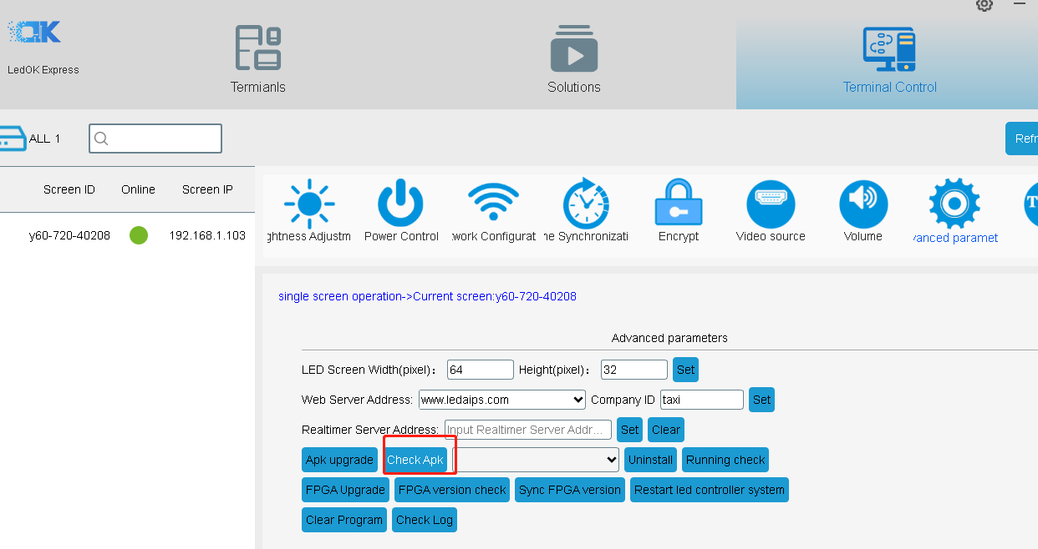

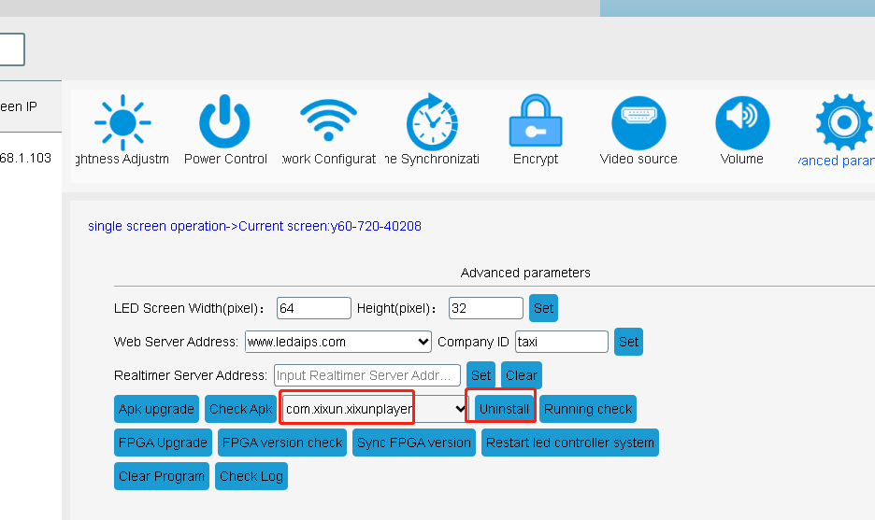

Also need uninstall Xwalk from the list, if the controller has the Xwalk. Steps are same.

1. Click APK upgrade option and select the portagain_E11_1.4.2.zip file and then click open

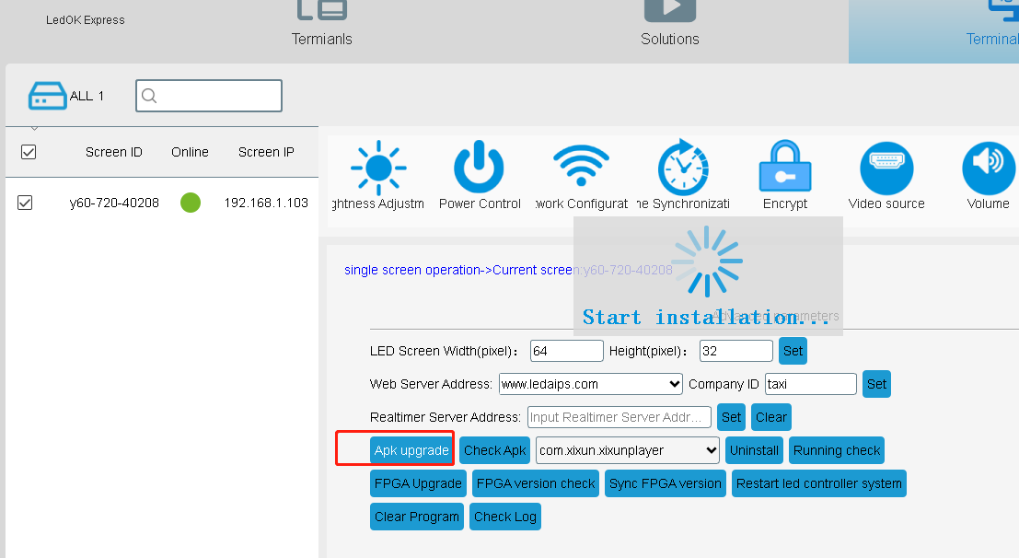

1. Waiting for 100% process and get the success message.
2. Click Check APK button and double check it install success

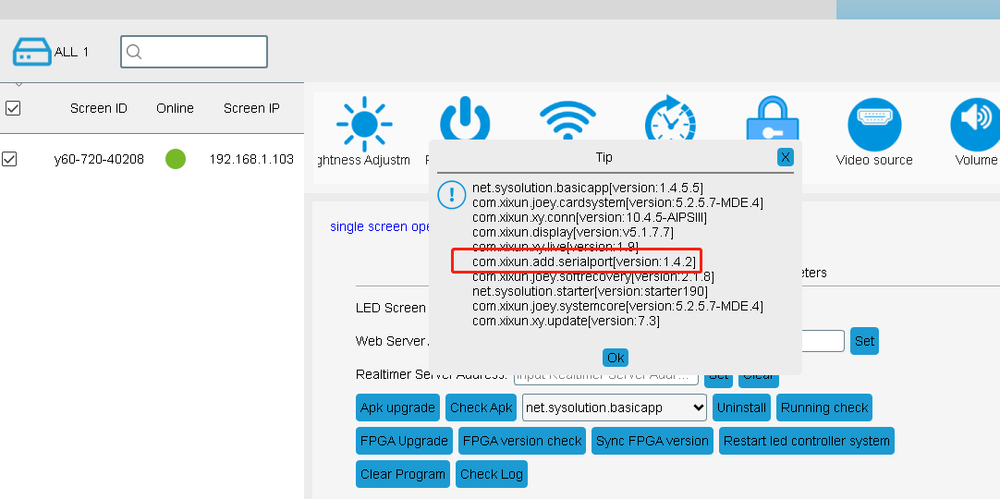

Then you can follow the protocols document and continue your work.